**MEMBERSHIP REPORT FOR FEBRUARY 19,2025 BOARD MEETING**

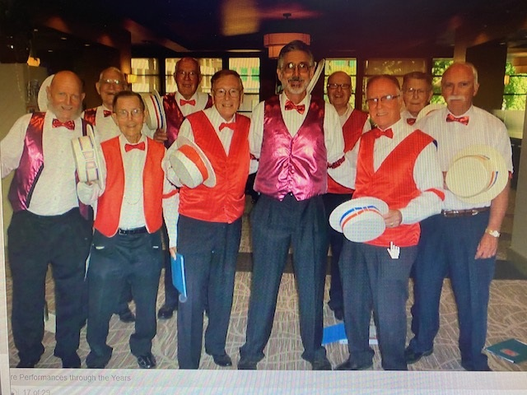

***Remembering Ross Brown:*** *February has been some month. The chorus is still reeling from the untimely passing of Ross Brown on 1/20/25. We are missing the questions and comments he always presented to the members and director. We always looked forward to his announcements before break on what was on sale at the market. Ross ran our 50- 50 for a long time. It is not quite the same with Ben Z.*

*Despite all of this, Ross has contributed to our chapter in many ways. He was a member of Encore (which was a group of about 16 mainly chorus members) who would perform at least once a month at senior living homes, assisted living, convalescent hospitals, as well as men and women church and social clubs, and at the V.A. hospital in the SFV just to name a few places. Encore started under the direction of Tom Mayfield in the early 90’s. When Tom moved out of state I volunteered as director and manager of Encore for the next 6 years. The money that Encore brought in went to several different places. Mainly the Barbershop Harmony Society Youth Program. It also went to our chapter, our rehearsal venue, and the Encore uniform. At the end of each year, we would treat the Encore members and their spouses to a wonderful luncheon at the Great Wall in Reseda. Over 40 people attended the luncheons.*

*The moto of Encore,* ***“Was to bring Joy where there was little”.***

*Ross also helped raise hundreds of dollars for our chapter through the years from his several connections. Mainly his stock brokers, business partners, friends, etc. He raised money for the chorus during Valentine Day, and during Christmas and other holiday swingouts. He helped the chorus out during our lean times. He was patriotic. He performed every year for Memorial Day. Despite his outburst at times, Ross was a good generous man who loved singing Barbershop music for 39 years both here and in Hawaii. Ross will be missed by all that really knew him.*

***Members Report:*** *This month we had several members in the hospital. Bob Karlin spent time there for apparently food poisoning. Then Dave Kirby had a knee replacement. Lastly, Kirk Prather slipped on the curb and fell on his head. He had to have it stitched up at the emergency. Then he went on a Cruise?*

*Also, Mark Nudelman is going through a lot of physical problems. He still has not had surgery on the leg due to complications from his Diabetes. I will keep everyone posted. At one of our rehearsals, this month, we only can 8 people.*

***Encino Farmers Market Swingout:*** *The manager of**ONEgenration Encino Farmers Market has allowed us the perform on the first and third week of each month. So far, we have performed 3 times. The last location was the most profitable. We made $57.00 in tips. This is surely extra money that the chorus needs for our monthly expenses. The nearby venue at the market has informed us that the earlier the better. That is as far as traffic is concerned in that location.*

***Valentine Day 2025****: I really do not know who performed this, Valentine Day. All in Accord was not able because Dave Kirby (tenor) voice was sore from the devices they had in his mouth while in the hospital. Also, Mark Nudelman was not available. I am not sure about the other quartets.*

*Our directors are doing a fine job preparing the chorus for our next event.*

*I especially enjoy our different warmup exercises each week.*

*A big thanks to Chuck Brooks for teaching us such wonderful tags.*

*We now have 17 participating members who are really working hard each week on their music. Let us keep up the good work.*

***Ben Marder, Membership VP. Valley Harmony Singers 2-18-25***