**Sean Chasworth, Musical Director**

Jeffery Bunch, Associate Director

Sean’s love for a Capella singing goes back to his honor choir participation in high school, at the University of Redlands, and the Los Robles Master Chorale at Moorpark College.

For 20 years, his home has been in Barbershop, including 15 years as the Assistant Director of Pasadena’s Crown City Chorus. During that time Sean sang in competitive quartets. He feels humbled and honored to be selected as Chorus Director of the award-winning Valley Harmony Singers, and hopes you enjoy and continue coming to our performances. Join us and share the joy of singing 4-part Harmony a Capella.

**WE MEET MONDAY EVENING 7:30 P.M.**

at St. Mark’s Episcopal Church 14646

Sherman Way, Van Nuys, CA. 91406 in the

Social Hall.

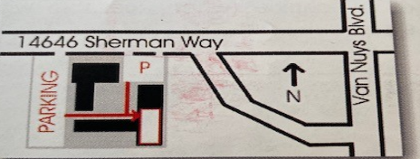

That’s 1-1/2 blocks west of Van Nuys Blvd. Parking lot is on the west side of the church on south side of street.

Come Join The

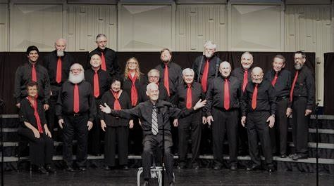

**Valley Harmony Singers**

For more information call

(818) 994-SING (7464)

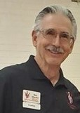valleyharmonysingers.org

**Ben Marder, Membership V.P.**

**EXPERIENCE THE THRILL OF 4-PART HARMONY**

**Come Sing with the**

San Fernando Valley Chapter, CA.



